SpringBoot Journal Application

- Downloaded SpringBoot jar from the start.spring.io
- Added dependencies like Spring Web to provide the API related functionalities also added Dev Tools to auto run the application on startup.
- Created an endpoint to check the health with( http://localhost:8080/health-check )
package com.subh.journalApp.controller;

import org.springframework.web.bind.annotation.GetMapping;
import org.springframework.web.bind.annotation.RestController;

@RestController
public class HealthCheck {
@GetMapping("health-check")
public String healthCheck() {
return "ok";
}
}

- To create the Journal, we need to specify their attributes such as Id, Title and Content. That is why the creation of a class containing the attribute is a great option.
package com.subh.journalApp.entity;

import org.springframework.stereotype.Component;

@Component
public class JournalEntry {

private long id;
private String title;
private String content;

public long getId() {
return id;
}

public void setId(long id) {
this.id = id;
}

public String getTitle() {
return title;
}

public void setTitle(String title) {
this.title = title;
}

public String getContent() {
return content;
}

public void setContent(String content) {
this.content = content;
}

}
// Note: I have marked this class as @Component but not necessary.
- To access this class, I have created a Controller classs

import org.springframework.web.bind.annotation.RequestMapping;
import org.springframework.web.bind.annotation.RestController;

import com.subh.journalApp.entity.JournalEntry;

@RestController
@RequestMapping("journal")
public class JournalEntryController {
}

//To access any endpoint, we have to go through http://localhost:8080/journal

- For now instead of creating a persistent database, we can create a HashMap to access the class

private Map<Long,JournalEntry> journalEntries=new HashMap<>();

- We can use various Http verbs like GET or PUT or POST or DELETE to access with the endpoint and access/manipulate the data.

- To create the endpoint we have to add mapping in the code.
- We can access the endpoints through talend/postman.
- Since there is a base url of journal, we can access at most 4 different and not duplicate mapping with journal. In case of 2 GetMapping- We need to add different mappings.
- Create Journal
@PostMapping
public boolean createEntry(@RequestBody JournalEntry myEntry) {
journalEntries.put(myEntry.getId(), myEntry);
return true;
}
Here you can see, I have created a @RequestBody JournalEntry myEntry, I can access that with postman and send JSON data.
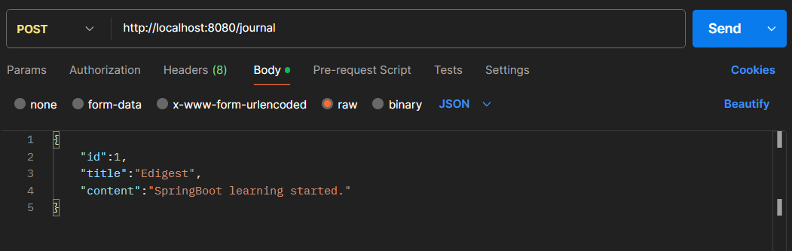
- Access journal
@GetMapping
public List<JournalEntry> getAll(){
return new ArrayList<>(journalEntries.values());
}

@GetMapping("id/{myId}")
public JournalEntry getJournalEntryById(@PathVariable Long myId) {
return journalEntries.get(myId);
}
Here PathVariable is used to specify variable during search.
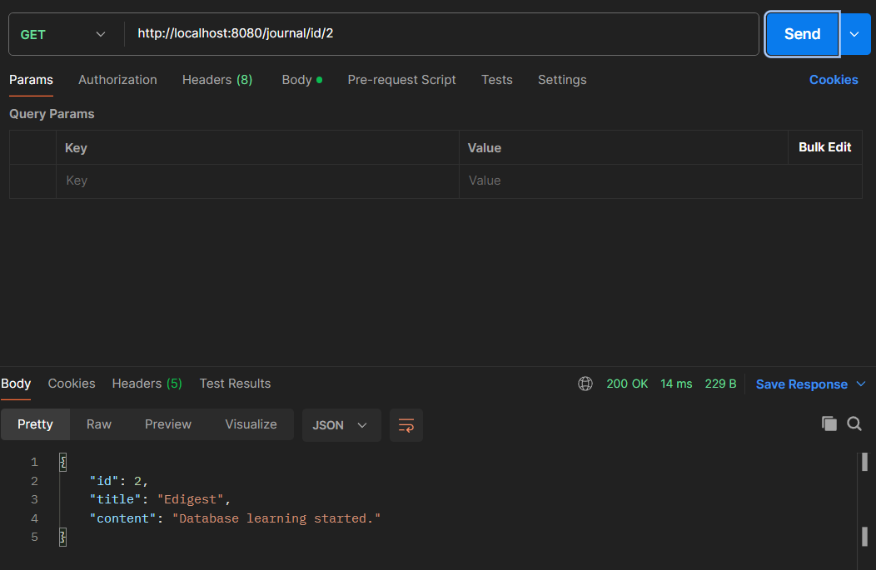

- The is also Delete mapping to delete and Put mapping to update.
@DeleteMapping("id/{myId}")
public boolean deleteJournalEntryById(@PathVariable Long myId) {
journalEntries.remove(myId);
return true;
}
@PutMapping("{id}")
public boolean updateJournalEntryById(@PathVariable Long id,@RequestBody JournalEntry myEntry) {
journalEntries.put(id, myEntry);
return true;
}

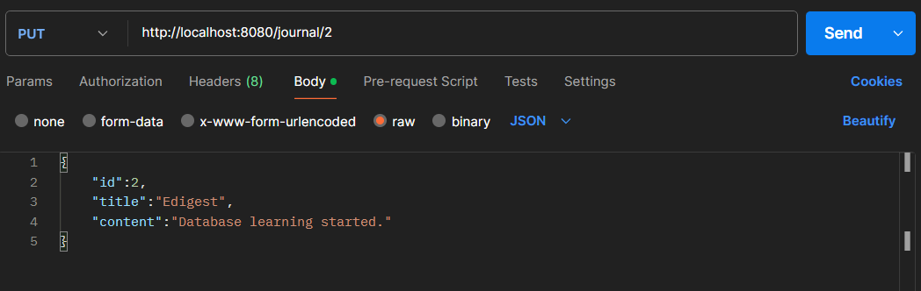

- Generally these type of approach is not persistence for data storage purpose, to store efficienty we need to use database.
- Generally for us, we need to focus on business logics instead of complex queries. For this ORM exists. ORM (It is a concept) stands for Object Relationship Mapping: it allows to map the class with a record. But it needs to follow some specifications as per JPA(It is a rule): Java Persistence API. It adds some interfaces. And Framework like HIBERNATE/ECLIPSE LINK is to achieve ORM, it provides JPA tools. Spring Data JPA is the add on for JPA(More Simplification).
- But as we are going to use MongoDb, We need Spring Data MongoDb for ODM(Object Document Mapping).
- To use MongoDb, we need to add dependency and some application property
<dependency>
<groupId>org.springframework.boot</groupId>
<artifactId>spring-boot-starter-data-mongodb</artifactId>
</dependency>

spring.data.mongodb.host=localhost
spring.data.mongodb.port=27017
spring.data.mongodb.database=journaldb

Even if there is no collection related to the journaldb, it will automatically get created. (You may also add username and password)

- The general approach
Controller ----> Service ----> Repository
In controller, we will add the endpoints. In Service, all the business logics will be written. And in the Repository, the ODM will be done.
We need some modification for JournalEntry class.
- Mapping of class to database
@Document
public class JournalEntry {

@Id
private ObjectId id;
private String title;
private String content;
private LocalDateTime date;

}
Here ObjectId (Datatype) is used because the MongoDb by default uses it to keep track of the documents. @Id ensures that, it is the key. @Document ensure it to be a structure for MongoDb collection.
- ODM (It is responsible for operation)
package com.subh.journalApp.repository;

import org.bson.types.ObjectId;
import org.springframework.data.mongodb.repository.MongoRepository;

import com.subh.journalApp.entity.JournalEntry;

public interface JournalEntryRepository extends MongoRepository<JournalEntry,ObjectId>{

}

A interface is used which extends MongoRepository<Class,Key>. This interface facilitates the feature like SpringDataJPA.
It means the object of this class can accept Data in the structure of JournalEntry and can perform actions such as findAll(), findById(), deleteById(), save().

- Service Layer
Service layer handles all the logics, even if we say that the operations can be done because of the Repository class but to make that happen,service is used. Repository = features. Service = Use the features.
Service layer keeps track of the instance of JournalEntryRepository, and performs operations with this.
@Component
public class JournalEntryService {

//Instance of Reposiroty
public JournalEntryService(JournalEntryRepository journalEntryRepository) {
super();
this.journalEntryRepository = journalEntryRepository;
}

private JournalEntryRepository journalEntryRepository;

//Save Journal
public void saveEntry(JournalEntry journalEntry) {
journalEntryRepository.save(journalEntry);
}

//find all entries
public List<JournalEntry> getAll(){
return journalEntryRepository.findAll();
}

//find single entity
//findById may return null, that is why Optional is used.
public Optional<JournalEntry> findById(ObjectId id) {
return journalEntryRepository.findById(id);
}

//delete entity
public void deleteById(ObjectId id) {
journalEntryRepository.deleteById(id);
}
}

- Controller
It is associated to Applicaton/presentaion layer of OSI. Contains endpoints, actual data is send to here. It accepts data and uses service to do the operations.
It keeps the instace of JournalEntryService and performs operations.
@RestController
@RequestMapping("journal")
public class JournalEntryControllerMongo {
public JournalEntryControllerMongo(JournalEntryService journalEntryService) {
super();
this.journalEntryService = journalEntryService;
}

private JournalEntryService journalEntryService;

@GetMapping
public List<JournalEntry> getAll(){
return journalEntryService.getAll();
}

@PostMapping
public JournalEntry createEntry(@RequestBody JournalEntry myEntry) {
myEntry.setDate(LocalDateTime.now());// Manually adding the date and time
journalEntryService.saveEntry(myEntry);
return myEntry;
}

@GetMapping("id/{myId}")
public JournalEntry getJournalEntryById(@PathVariable ObjectId myId) {
return journalEntryService.findById(myId).orElse(null); //return type of FindById is //is optional,so it may return //null
}

@DeleteMapping("id/{myId}")
public boolean deleteJournalEntryById(@PathVariable ObjectId myId) {
journalEntryService.deleteById(myId);
return true;
}

@PutMapping("{id}")
public JournalEntry updateJournalEntryById(@PathVariable ObjectId id,@RequestBody JournalEntry newEntry) {

JournalEntry oldEntry=journalEntryService.findById(id).orElse(null);

if(oldEntry!=null) {

oldEntry.setTitle(newEntry.getTitle()!=null && !newEntry.getTitle().equals("") ? newEntry.getTitle():oldEntry.getTitle());

oldEntry.setContent(newEntry.getContent()!=null && !newEntry.getContent().equals("") ? newEntry.getContent():oldEntry.getContent());

}

journalEntryService.saveEntry(oldEntry);
return oldEntry;
}
}

Here the JournalEntry is fetched using findById. If not null then operations are performed. Operations inlcude:
- Changing the title
- Changing the content

- Id of Mongodb is Object id.
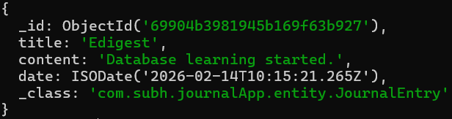

- Status Code
These are the extra details about the response. Includes XXX and of 5 types.
- 1XX----> Informative
- 2XX----> Successful Request
Successful Ok, 201- Created, 204- no content
- 3XX----> Redirection
Moved permanently, 302- Temporarily redirect
- 4XX----> Error from Client
Bad Request, 401- Unauthorized, 403- Forbidden, 404- Not Found
- 5xx----> Server error

To add these status code as a part of request and response, we can add ResponseEntity. It is similar to a wrapper, along with the actual data it adds the status code.
Function datatype : ResponseEntity<JournalEntry or ?> : ? means wildcard (used when read or delete, I.e type is not necessary)
Function return : new ResponseEntity<>(object,HttpStatus.CODE)
@GetMapping
public ResponseEntity<List<JournalEntry>> getAll(){
List<JournalEntry> entries=journalEntryService.getAll();
if(entries!=null && !entries.isEmpty()) {
return new ResponseEntity<>(entries,HttpStatus.OK);
}
return new ResponseEntity<>(HttpStatus.NOT_FOUND);
}

@PostMapping
public ResponseEntity<JournalEntry> createEntry(@RequestBody JournalEntry myEntry) {
try {
myEntry.setDate(LocalDateTime.now());
journalEntryService.saveEntry(myEntry);
return new ResponseEntity<>(myEntry,HttpStatus.CREATED);
}
catch(Exception e) {
return new ResponseEntity<>(HttpStatus.BAD_REQUEST);
}
}

@GetMapping("id/{myId}")
public ResponseEntity<JournalEntry> getJournalEntryById(@PathVariable ObjectId myId) {
Optional<JournalEntry> entry= journalEntryService.findById(myId);
if(entry.isPresent()) {
return new ResponseEntity<>(entry.get(),HttpStatus.OK);
}
return new ResponseEntity<>(HttpStatus.NOT_FOUND);
}

@DeleteMapping("id/{myId}")
public ResponseEntity<?> deleteJournalEntryById(@PathVariable ObjectId myId) {
journalEntryService.deleteById(myId);
return new ResponseEntity<>(HttpStatus.NO_CONTENT);
}

@PutMapping("{id}")
public ResponseEntity<JournalEntry> updateJournalEntryById(@PathVariable ObjectId id,@RequestBody JournalEntry newEntry) {
JournalEntry oldEntry=journalEntryService.findById(id).orElse(null);
if(oldEntry!=null) {
oldEntry.setTitle(newEntry.getTitle()!=null && !newEntry.getTitle().equals("")?newEntry.getTitle():oldEntry.getTitle());
oldEntry.setContent(newEntry.getContent()!=null && !newEntry.getContent().equals("")?newEntry.getContent():oldEntry.getContent());
journalEntryService.saveEntry(oldEntry);
return new ResponseEntity<>(oldEntry,HttpStatus.OK);
}
return new ResponseEntity<>(HttpStatus.NOT_FOUND);
}

- Project Lombok
To reduce the boilerplate code, we use project lombok. It contains some annotation, which reduces the need of Getter/Setter/Constructor/ToString etc.
Some annotations are : @Data, @Getter, @Setter, @AllArgsConstructor, @NoArgsConstructor etc.
@Component
@Document
@Data
public class JournalEntry {
@Id
private ObjectId id;
private String title;
private String content;
private LocalDateTime date;
}

@AllArgsConstructor
public class JournalEntryControllerMongo {

private JournalEntryService journalEntryService;
. . . . . . . .
}

- User Integration
For a jounal app, we need to add users. A particular user has some journals, no users can see the journals of different user.

@Document
@Data
@NoArgsConstructor
public class User {
@Id
private ObjectId id;
@Indexed(unique = true)
@NonNull
private String username;
@NonNull
private String password;
@DBRef
private List<JournalEntry> journals=new ArrayList<>();
}

Here @NonNull belongs to lombok, it ensures that the fields are not empty during the runtime.
@Indexed(unique=true) ensures that the field is unique always. But also with this, we need to add spring.data.mongodb.auto-index-creatiom=true.
@DbRef is used to link the field of user with JournalEntry as (“journalEntry”,”Object_Id”)
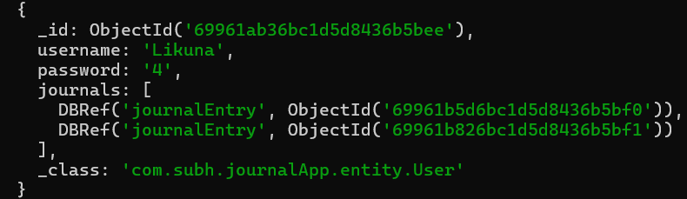
To use Object Document Mapping features, we need to use a interfaces extended to MongoRepository<User,ObjectId>
public interface UserRepository extends MongoRepository<User, ObjectId> {
User findByUsername(String userName);
}
Here findByUsername is a custom method. User stands for return type, username is argument

This interface is accessed by userService to create, delete,fetch user/users.
THE USER SERVICE
@Component
@AllArgsConstructor
public class UserService {

private UserRepository userRepository;
private JournalEntryService journalEntryService;

public void saveUser(User user){
userRepository.save(user);
}

public List<User> findUsers(){
return userRepository.findAll();
}

public Optional<User> findById(ObjectId id) {
return userRepository.findById(id);
}

public User findByUsername(String username) {
return userRepository.findByUsername(username);
}

public void deleteUser(String username) {
User user=userRepository.findByUsername(username);
if(user!=null) {
userRepository.deleteById(user.getId());
}
}
}

In deletion we ensure that, whenever we delete a user then all the posts associated with that user is also gets deleted.

Similary, we can not store a journal randomly. We need to associate journal specific to a user. Whenever we access the journal, we need to access through journal. Whenever we delete the journal of a user we need to make sure that the reference I.e objectId is also gets deleted in the user field. Since we are using MongoDb a non relational database, the references are not deleted automatically.

THE JOURNALENTRY SERVICE
@Component
@AllArgsConstructor
public class JournalEntryService {

private JournalEntryRepository journalEntryRepository;
private UserService userService;

//fetching the user, saving the journal, adding the journal into the entries field of //user then saving user.
public void saveEntry(JournalEntry journalEntry, String username) {
User user=userService.findByUsername(username);
journalEntry.setDate(LocalDateTime.now());
journalEntryRepository.save(journalEntry);
user.getJournals().add(journalEntry);
userService.saveUser(user);
}

//For Put Mapping
public void saveEntry(JournalEntry journalEntry) {
journalEntryRepository.save(journalEntry);
}

//Not used for now
public List<JournalEntry> getAll(){
return journalEntryRepository.findAll();
}

//Deleting all journals for a user
public void deleteAllJournals(String username) {
User user=userService.findByUsername(username);
if(user!=null) {
for(JournalEntry al:user.getJournals()) {
journalEntryRepository.deleteById(al.getId());
}
}
}

//Fetch the user, if user is not null and the id of journal belongs to the journals of user then fetch the journal
public Optional<JournalEntry> findById(ObjectId id,String username) {
User user = userService.findByUsername(username);
if (user != null && user.getJournals().stream().anyMatch(journal -> journal.getId().equals(id))) {
return journalEntryRepository.findById(id);
}
return null;
}

//Fetch the user, if user is not null and the id of journal belongs to the journals of user then delete the journal remove id from user and save user
public void deleteById(ObjectId id, String username) {
User user = userService.findByUsername(username);
if (user != null && user.getJournals().stream().anyMatch(journal -> journal.getId().equals(id))) {
user.getJournals().removeIf(journal->journal.getId().equals(id));
journalEntryRepository.deleteById(id);
userService.saveUser(user);
}
}
}

The USER CONTROLLER
@RestController
@AllArgsConstructor
@RequestMapping("/user")
public class UserController {
private UserService userService;
private JournalEntryService journalEntryService;

//find all users
@GetMapping
public ResponseEntity<List<User>> findAllUsers(){
try {
return new ResponseEntity<>(userService.findUsers(),HttpStatus.OK);
}
catch(Exception e) {
return new ResponseEntity<>(HttpStatus.BAD_REQUEST);
}
}

//create user
@PostMapping
public ResponseEntity<User> createUser(@RequestBody User user) {
try {
userService.saveUser(user);
return new ResponseEntity<>(user,HttpStatus.CREATED);
}
catch (Exception e) {
return new ResponseEntity<>(HttpStatus.BAD_REQUEST);
}
}

//delete user
In deletion we ensure that, whenever we delete a user then all the posts associated with that user is also gets deleted.

Similary, we can not store a journal randomly. We need to associate journal specific to a user. Whenever we access the journal, we need to access through journal. Whenever we delete the journal of a user we need to make sure that the reference I.e objectId is also gets deleted in the user field. Since we are using MongoDb a non relational database, the references are not deleted automatically.

@DeleteMapping("/{username}")
public ResponseEntity<?> deleteUser(@PathVariable String username) {
try {
journalEntryService.deleteAllJournals(username);//delete all journals of a user
userService.deleteUser(username);//delete user
return new ResponseEntity<>(HttpStatus.NO_CONTENT);
}
catch(Exception e) {
return new ResponseEntity<>(HttpStatus.BAD_REQUEST);
}
}

//find a particular user
@GetMapping("/{username}")
public ResponseEntity<User> findUser(@PathVariable String username) {
try {
User user=userService.findByUsername(username);
if(user!=null) {
return new ResponseEntity<>(user,HttpStatus.OK);
}
else {
throw new Exception("User not found");
}
}
catch(Exception e) {
return new ResponseEntity<>(HttpStatus.NO_CONTENT);
}
}

//update username and password of a user.
@PutMapping("/{username}")
public ResponseEntity<User> updateUser(@PathVariable String username, @RequestBody User newUser) {
try {
User userInDb=userService.findByUsername(username);
if(userInDb!=null) {
userInDb.setUsername(newUser.getUsername());
userInDb.setPassword(newUser.getPassword());
userService.saveUser(userInDb);
}
return new ResponseEntity<>(userInDb,HttpStatus.OK);
}
catch (Exception e) {
return new ResponseEntity<>(HttpStatus.BAD_REQUEST);
}
}
}

THE JOURNAL ENTRY CONTROLLER
@RestController
@RequestMapping("journal")
@AllArgsConstructor
public class JournalEntryControllerMongo {

private JournalEntryService journalEntryService;
private UserService userService;

//Fetch all journals of a user
@GetMapping("/{username}")
public ResponseEntity<List<JournalEntry>> getAll(@PathVariable String username) {
User user = userService.findByUsername(username);
List<JournalEntry> entries = user.getJournals();
if (entries != null && !entries.isEmpty()) {
return new ResponseEntity<>(entries, HttpStatus.OK);
}
return new ResponseEntity<>(HttpStatus.NOT_FOUND);
}

//Add journal under a user
@PostMapping("/{username}")
public ResponseEntity<JournalEntry> createEntry(@RequestBody JournalEntry myEntry, @PathVariable String username) {
try {
journalEntryService.saveEntry(myEntry, username);
return new ResponseEntity<>(myEntry, HttpStatus.CREATED);
} catch (Exception e) {
return new ResponseEntity<>(HttpStatus.BAD_REQUEST);
}
}

//Fetch specific journal of a user
@GetMapping("{username}/{myId}")
public ResponseEntity<JournalEntry> getJournalEntryById(@PathVariable ObjectId myId,
@PathVariable String username) {
Optional<JournalEntry> entry = journalEntryService.findById(myId, username);
if (entry!=null && entry.isPresent()) {
return new ResponseEntity<>(entry.get(), HttpStatus.OK);
}
return new ResponseEntity<>(HttpStatus.NOT_FOUND);
}

//delete journal of a specific user
@DeleteMapping("/{username}/{myId}")
public ResponseEntity<?> deleteJournalEntryById(@PathVariable ObjectId myId,@PathVariable String username) {
journalEntryService.deleteById(myId,username);
return new ResponseEntity<>(HttpStatus.NO_CONTENT);
}

//Update journal of a user
@PutMapping("/{username}/{id}")
public ResponseEntity<JournalEntry> updateJournalEntryById(@PathVariable ObjectId id,
@RequestBody JournalEntry newEntry,@PathVariable String username) {
JournalEntry oldEntry = journalEntryService.findById(id,username).orElse(null);
if (oldEntry != null) {
oldEntry.setTitle(newEntry.getTitle() != null && !newEntry.getTitle().equals("") ? newEntry.getTitle()
: oldEntry.getTitle());
oldEntry.setContent(
newEntry.getContent() != null && !newEntry.getContent().equals("") ? newEntry.getContent()
: oldEntry.getContent());
journalEntryService.saveEntry(oldEntry);
return new ResponseEntity<>(oldEntry, HttpStatus.OK);
}

return new ResponseEntity<>(HttpStatus.NOT_FOUND);
}
}

Object Id returning method

It is very tiresome to check mongodb again and again, so I have created a endpoint to access the objectId.
The challenges that I faced are : Whenever I was trying to return the objectId, it was giving me json serialized objec with date field. But mongo objectID is 12 bit hexadecimal string.
To get that

public String objectId(String username, String title) {
User user = userService.findByUsername(username);
return user.getJournals().stream().filter(journal -> journal.getTitle().equals(title))
.map(journal -> journal.getId().toHexString()).findFirst()
.orElse(null);
}

The endpoint is :
@GetMapping("id/{username}/{title}")
public ResponseEntity<String> objectId(@PathVariable String username,
@PathVariable String title) {
try {
return new ResponseEntity<>(journalEntryService.objectId(username, title),HttpStatus.OK);
}
catch (Exception e) {
return new ResponseEntity<>(HttpStatus.NOT_FOUND);
}
}

To Achieve Atomicity

We need to have a replication method, which will store the old values incase any error occurs. For this we can use Mongodb Atlas, it’s a cloud data storage for mongodb. But to achieve the exact atomicity, we need to add @Transactional on the methods(such as : create or save or update) we need to achieve atomicity.
Alone Transactional annotation is not sufficient, we need to have a mecanism to manage transactions. So a class needs to be annotated with @EnableTransationManagement. And there should be method of type PlatformTransactionManager(It is a interface which defines commit and rollback mechanism but not the implementation) which will hold the instance of the connection: Here MongoDatabaseFactory (Instance of connection) and returns the MongoTransactionManager: it is the actual implementation of transaction manager.

@SpringBootApplication
@EnableTransactionManagement
public class JournalApplication {

public static void main(String[] args) {
SpringApplication.run(JournalApplication.class, args);
}
@Bean
public PlatformTransactionManager atomicity(MongoDatabaseFactory dbFactory) {
return new MongoTransactionManager(dbFactory);
}

}

@Transactional
public void saveEntry(JournalEntry journalEntry, String username) {
User user = userService.findByUsername(username);
journalEntry.setDate(LocalDateTime.now());
journalEntryRepository.save(journalEntry);
user.getJournals().add(journalEntry);
userService.saveUser(user);
}

Adding Spring Security

To enable authentication and authorization. We can not allow everyone to access the endpoints freely, so we need some restrictions.

Spring Security Dependency

<dependency>
<groupId>org.springframework.boot</groupId>
<artifactId>spring-boot-starter-security</artifactId>
</dependency>

It will automatically create a username as user and random password in output logs.
We can manually change is 2 ways:

- application.properties
spring.security.user.name=username
spring.security.user.password=password

- Custom user details
When the authentication occurs, the default Security looks for UserDetailsService implementaion to fetch user data. Initial step is to create a new UserDetailsService. For this let a class implemet the UserDetailsService then we can override the getUserDetails(username) method to fetch the user from db and build a UserDetails object which we can send to Spring Security.

@Component
public class UserDetailsServiceImpl implements UserDetailsService{
@Autowired
public UserRepository userRepository;
@Override
public UserDetails loadUserByUsername(String username) throws UsernameNotFoundException {
User user=userRepository.findByUsername(username);
if(user!=null) {
UserDetails userDetails=org.springframework.security.core.userdetails.User.builder()
.username(user.getUsername())
.password(user.getPassword())
.roles(user.getRoles().toArray(new String[0]))
.build();
return userDetails;
}
throw new UsernameNotFoundException("User does not exist");
}
}

Here we fetched the userdetails from db using the UserRepository and findByUsername method.

But only creating the custom UserDetailsService won’t be added to the security, we need some configuration to let the AuthenticationManagerBuilder access this UserDetailsService class.
Hence we’ll create a configuration class for Spring Security. Here we can add SecurityFilterChain -> It’ll tell about the authorizations of endpoints. We can also use it to enable or disable Cross Site Request Forgery(csfr).

@Component
@EnableWebSecurity
public class SpringSecurity {
@Autowired
private UserDetailsService userDetailsService;
//Endpoints management
@Bean
public SecurityFilterChain securityFilterChain(HttpSecurity http) throws Exception{
return http.authorizeHttpRequests(request->request
.requestMatchers("/public/**").permitAll()
.requestMatchers("/journal/**","/user/**").authenticated()
.requestMatchers("/admin/**").hasRole("ADMIN")
.anyRequest().authenticated())
.httpBasic(Customizer.withDefaults())
.csrf(AbstractHttpConfigurer::disable)
.build();
}
//using the modified UserDetailsService
//by default the auth from header comes here to ask about the userdetails
//Auth username + Auth password with the encoder used here are used as dummy credentials
//these are validated against the modified UserDetailsServiceImpl
@Autowired
public void configureGlobal(AuthenticationManagerBuilder auth) throws Exception{
auth.userDetailsService(userDetailsService).passwordEncoder(passwordEncoder());
}
public PasswordEncoder passwordEncoder() {
return new BCryptPasswordEncoder();
}
}
Here multiple . are meant for chaining of methods.
- requestMatchers("/public/**").permitAll() -> means all endpoints with public require no auth.
- requestMatchers("/journal/**","/user/**").authenticated() -> needs authentication
- httpBasic(Customizer.withDefaults()) -> enable Basic Authentication
- csrf(AbstractHttpConfigurer::disable) -> disable csrf
- .build() -> build the SecurityFilterChain

@Autowired
public void configureGlobal(AuthenticationManagerBuilder auth) throws Exception{
auth.userDetailsService(userDetailsService).passwordEncoder(passwordEncoder());
}

This part is Autowired means the AuthenticationManagerBuilder bean is injected and we tell this object to use our userDetailsService class to load userDetails and use the passwordEncoder() function for matching of the password we had sent during Basic Authentication.

auth.userDetailsService(The object we specify)-> tells to fetch the user from the class
auth.userDetailsService(userDetailsService).passwordEncoder(passwordEncoder())-> tells
While passwordEncoder.matches(rawPassword, encodedPasswordFromDB). use our encoder in case of matching.
raw
Username: subh
Password: 123

indb
{
"username": "subh",
"password": "$2a$10$abcxyz....."
}

Public EndPoints
Creation of user should be public, and no need to pass the username from parameters.
private UserService userService;

@PostMapping("create-user")
public ResponseEntity<User> createUser(@RequestBody User user) {
try {
userService.saveNewUser(user);
return new ResponseEntity<>(user, HttpStatus.CREATED);
}
catch (Exception e) {
return new ResponseEntity<>(HttpStatus.BAD_REQUEST);
}
}

public void saveNewUser(User user){
user.setPassword(passwordEncoder.encode(user.getPassword()));
user.setRoles(Arrays.asList("USER"));
userRepository.save(user);
}

Other Operations
Once authenticated, From the securitycontext holder we can get the user details to perform delete/update

UserDetails userDetails=SecurityContextHolder.getContext().getAuthentication();
We also need to build 2 methods to save user : saveNewUser and saveUser.
To save/update password we can use saveNewUser and when we add journal to a user then only save user without encryption needed.
@RestController
@AllArgsConstructor
@RequestMapping("/user")
public class UserController {
private UserService userService;

@Transactional
@DeleteMapping
public ResponseEntity<?> deleteUser() {
Authentication authentication = SecurityContextHolder.getContext().getAuthentication();
String username=authentication.getName();
journalEntryService.deleteAllJournals(username);
userService.deleteByUsername(username);
return new ResponseEntity<>(HttpStatus.NO_CONTENT);
}
//Deletion ensure both user and journals related to the user are deleted.
@PutMapping
public ResponseEntity<User> updateUser(@RequestBody User newUser) {
Authentication authentication = SecurityContextHolder.getContext().getAuthentication();
String username = authentication.getName();
try {
User userInDb = userService.findByUsername(username);
if (userInDb != null) {
userInDb.setUsername(newUser.getUsername());
userInDb.setPassword(newUser.getPassword());
userService.saveNewUser(userInDb);
}
return new ResponseEntity<>(userInDb, HttpStatus.OK);
}
catch (Exception e) {
return new ResponseEntity<>(HttpStatus.BAD_REQUEST);
}
}
}

Added service to deleteByUsername in UserService
public void deleteByUsername(String username) {
userRepository.deleteByUsername(username);
}

But created in UserRepository
void deleteByUsername(String username);

Adding the authentication in the JournalEntryController
During the creation of journal related service I created a good thing that, I was checking the journal lists of user like:
public Optional<JournalEntry> findById(ObjectId id, String username) {
User user = userService.findByUsername(username);
if (user != null && user.getJournals().stream().anyMatch(journal -> journal.getId().equals(id))) {
return journalEntryRepository.findById(id);
}
I mean even if we find the id of a journal of different user, we can not do anything cause we are checking if the current user contains the journal by
User.getJournals().stream().anyMatch(journal->journal.getId().equals(myId)) then returns the journalEntryRepository.findById(id);

For deletion also
@Transactional
public boolean deleteById(ObjectId id, String username) {
boolean removed=false;
User user = userService.findByUsername(username);
if (user != null && user.getJournals().stream().anyMatch(journal -> journal.getId().equals(id))) {
journalEntryRepository.deleteById(id);
removed=user.getJournals().removeIf(journal -> journal.getId().equals(id));
userService.saveUser(user);
}
return removed;
}

Now to add auth in JournalEntry Endpoints, we only need to change the controllers a bit not much we can get the username from spring security context holder

@RestController
@RequestMapping("journal")
@AllArgsConstructor
public class JournalEntryControllerMongo {

private JournalEntryService journalEntryService;
private UserService userService;

@GetMapping
public ResponseEntity<List<JournalEntry>> getAll() {
Authentication authentication=SecurityContextHolder.getContext().getAuthentication();
String username=authentication.getName();
User user = userService.findByUsername(username);
List<JournalEntry> entries = user.getJournals();
if (entries != null && !entries.isEmpty()) {
return new ResponseEntity<>(entries, HttpStatus.OK);
}
return new ResponseEntity<>(HttpStatus.NOT_FOUND);
}

@PostMapping
public ResponseEntity<JournalEntry> createEntry(@RequestBody JournalEntry myEntry) {
Authentication authentication=SecurityContextHolder.getContext().getAuthentication();
String username=authentication.getName();
try {
journalEntryService.saveEntry(myEntry, username);
return new ResponseEntity<>(myEntry, HttpStatus.CREATED);
}
catch (Exception e) {
return new ResponseEntity<>(HttpStatus.BAD_REQUEST);
}
}

@GetMapping("{myId}")
public ResponseEntity<JournalEntry> getJournalEntryById(@PathVariable ObjectId myId) {
Authentication authentication=SecurityContextHolder.getContext().getAuthentication();
String username=authentication.getName();
Optional<JournalEntry> entry = journalEntryService.findById(myId, username);
if (entry!=null && entry.isPresent()) {
return new ResponseEntity<>(entry.get(), HttpStatus.OK);
}
return new ResponseEntity<>(HttpStatus.NOT_FOUND);
}

@DeleteMapping("{myId}")
public ResponseEntity<Boolean> deleteJournalEntryById(@PathVariable ObjectId myId) {
Authentication authentication=SecurityContextHolder.getContext().getAuthentication();
String username=authentication.getName();
boolean removed=journalEntryService.deleteById(myId,username);
if(removed) {
return new ResponseEntity<>(HttpStatus.NO_CONTENT);
}
return new ResponseEntity<>(HttpStatus.NOT_FOUND);
}

@PutMapping("{id}")
public ResponseEntity<JournalEntry> updateJournalEntryById(@PathVariable ObjectId id,
@RequestBody JournalEntry newEntry) {
Authentication authentication=SecurityContextHolder.getContext().getAuthentication();
String username=authentication.getName();
JournalEntry oldEntry = journalEntryService.findById(id,username).orElse(null);
if (oldEntry != null) {
oldEntry.setTitle(newEntry.getTitle() != null && !newEntry.getTitle().equals("") ? newEntry.getTitle():oldEntry.getTitle());
oldEntry.setContent(newEntry.getContent()!=null&&!newEntry.getContent().equals("") ?newEntry.getContent():oldEntry.getContent());
journalEntryService.saveEntry(oldEntry);
return new ResponseEntity<>(oldEntry, HttpStatus.OK);
}

return new ResponseEntity<>(HttpStatus.NOT_FOUND);
}
@GetMapping("id/{title}")
public ResponseEntity<String> objectId(@PathVariable String title) {
Authentication authentication=SecurityContextHolder.getContext().getAuthentication();
String username=authentication.getName();
try {
return new ResponseEntity<>(journalEntryService.objectIdOfJournal(username, title),HttpStatus.OK);
}
catch (Exception e) {
return new ResponseEntity<>(HttpStatus.NOT_FOUND);
}
}
}

Adding ADMIN ACCESS
Adding admin access is nothing but the play of API, Service and Controller. Some service like find all users are easy to implement like

public List<User> findUsers() {
return userRepository.findAll();
}

We can also create a service for admin creation where ADMIN role should be mentioned like :
public void saveAdminUser(User user) {
user.setPassword(passwordEncoder.encode(user.getPassword()));
user.setRoles(Arrays.asList("USER","ADMIN"));
userRepository.save(user);
}
Only thing left is use controller to call these services

@RestController
@RequestMapping("admin")
@AllArgsConstructor
public class AdminController {

private UserService userService;

@PostMapping("/create-admin-user")
public ResponseEntity<?> createAdmin(@RequestBody User user) {
try {
userService.saveAdminUser(user);
return new ResponseEntity<>(HttpStatus.CREATED);
}
catch (Exception e) {
return new ResponseEntity<>(HttpStatus.FORBIDDEN);
}
}

@GetMapping("/all-users")
public ResponseEntity<?> getAllUsers() {

List<User> users = userService.findUsers();
if (users != null && !users.isEmpty()) {
return new ResponseEntity<>(users, HttpStatus.OK);
}

return new ResponseEntity<>(HttpStatus.NOT_FOUND);
}

@Transactional
@DeleteMapping("/all-users")
public ResponseEntity<?> deleteAllUsers() {

List<User> users = userService.findUsers();
if (users != null && !users.isEmpty()) {
for(User user:users) {
userService.deleteByUsername(user.getUsername());
}
return new ResponseEntity<>(users, HttpStatus.NO_CONTENT);
}

return new ResponseEntity<>(HttpStatus.FORBIDDEN);
}
}

To use Maven Command
Generally to use maven command there are multiple options as: we can run as maven build from the run option and then we can run through the command line but go to the directory mentioned like
cd /d D:\SpringBoot Revision\journalApp
Then use mvnw <command>

Application Configurations

There are multiple ways to configure applications such as:
- application.properties
->Uses the dot notations to use the exact class and field property method.
->Example : spring.data.moongodb.auto-index-creation=true

- application.yml
->Uses the colon and indentations to show the class and field property method.
->Example : spring:
data:
mongodb:
auto-index-creation: true
->Remember,it uses 2 spaces before and after :, there should be a space

- Command line argument
->It is used to pass the properties at runtime.
->Example : java --jar ./___Build File Name____.jar
java -jar my-app.jar --server.port=9090

- Run configurations
->Add in program arguments

Priority:
CLA>Run Configs>application.properties>application.yml

JUNIT
This is a unit test framework build for the java, purpose is to use test the methods independently.
Some annotations:
@SpringBootTest-> Since test does not call the spring boot applications, the objects are not handled by IOC container, This annotation initializes the IOC container.
@Test->Enables a method for testing.
@Disable->Disables the test.
@BeforeEach->Before each test, it is initialised. Similarly AfterEach at the last of each test.
@BeforeAll->Used before static method and once initialsed at class loading.
@AfterAll->Used for cleanup.
@CsvSource(“1,1,1”,”2,2,2”)
@ValueSource(String={
“Ram”,
“Shyam”
})
@ArgumentSource(X.class) //X is the class where argument is defined
X implements the ArgumentProvider and overrides a method to provide custom arguments as:
Return Stream.of(Argumemts.of(1,1,1),Arguments.of(2,2,2));

Objects can be created and sent as arguments without constructors as builders, Builder is a static class under a class whose object we want to create. It uses getters and setters to create object parameter initialise.

class User {

private String name;
private int age;
private String email;

private User(Builder builder) {
this.name = builder.name;
this.age = builder.age;
this.email = builder.email;
}

public static class Builder {

private String name;
private int age;
private String email;

public Builder name(String name) {
this.name = name;
return this;
}

public Builder age(int age) {
this.age = age;
return this;
}

public Builder email(String email) {
this.email = email;
return this;
}

public User build() {
return new User(this);
}
}
}

Some testing methods:
Asserts -> assertEquals, assertNotNull, assertTrue etc etc.
In a single userdefined method if a single asert statement is failed the the subsequent assert methods will not work. To check all assert methods use
assertAll(
()->assertTrue(…),
()->assertNotNull(…)
);

For this class
package com.subh.journalApp.service;

import static org.junit.jupiter.api.Assertions.assertAll;
import static org.junit.jupiter.api.Assertions.assertEquals;
import static org.junit.jupiter.api.Assertions.assertNotNull;

import org.junit.jupiter.api.AfterEach;
import org.junit.jupiter.api.BeforeEach;
import org.junit.jupiter.api.Disabled;
import org.junit.jupiter.api.Test;
import org.junit.jupiter.params.ParameterizedTest;
import org.junit.jupiter.params.provider.ArgumentsSource;
import org.junit.jupiter.params.provider.CsvSource;
import org.springframework.beans.factory.annotation.Autowired;
import org.springframework.boot.test.context.SpringBootTest;

import com.subh.journalApp.entity.User;
import com.subh.journalApp.repository.UserRepository;

@SpringBootTest
public class UserServiceTest {
@Autowired
private UserRepository userRepository;
private User user;
@Disabled
@BeforeEach
public void initialiseUser() {
user=userRepository.findByUsername("Bikash");
}

@Disabled
@Test
public void testFindByUsername() {
assertAll(
()->assertNotNull(userRepository.findByUsername("Bikash")),
()->assertNotNull(userRepository.findByUsername("Likuna"))
);
}

@Disabled
@Test
public void testJournalsOfAUser() {
assertNotNull(user.getJournals());
}

@Disabled
@AfterEach
public void deleteUser() {
user=null;
System.out.println("User is "+user);
}

@Disabled
@ParameterizedTest
@CsvSource({
"1,1,2",
"2,2,4",
"2,2,8"
})
public void add(int a, int b, int result) {
assertEquals(a+b, result);
}

@ParameterizedTest
@ArgumentsSource(CalculatorArguments.class)
public void addFromSrc(Calculator calculator) {
assertEquals(calculator.getA() + calculator.getB(), calculator.getResult());
}
}

public class CalculatorArguments implements ArgumentsProvider{
@Override
public Stream<? extends Arguments> provideArguments(ExtensionContext context) throws Exception {
return Stream.of(
Arguments.of(Calculator.builder().a(1).b(1).result(2).build()),
Arguments.of(Calculator.builder().a(2).b(1).result(3).build()),
Arguments.of(Calculator.builder().a(1).b(1).result(3).build())
);
}
}

Mockito

A framework for testing. Instead of fetching the actual service, we can mock the service with certain methods.
Example:
I want to mock userRepository, then I can use @MockBean before initialising the variable and when intercepting the variable we can do certain actions such as:
When(userRepository.findByUsername(ArgumentMatchers.anyString())).thenReturn(user.builder().username()…..build())

@SpringBootTest
public class UserDetailsServiceImplTest {
@Autowired
private UserDetailsServiceImpl detailsServiceImpl;
@MockBean
private UserRepository userRepository;
@Test
void loadByUsername() {
when(userRepository.findByUsername(ArgumentMatchers.anyString())).thenReturn(com.subh.journalApp.entity.User.builder().username("Ram").password("rammm").roles(new ArrayList<>()).build());
UserDetails user=detailsServiceImpl.loadUserByUsername("Ram");
assertNotNull(user);
}
}

But it initialises the whole project where we need to use only 2 classes. We can use InjectMocks-> mocks the marked class.
Mock->similar to mockbean
@ExtendWith(MockitoExtension.class) -> Initialises the mock
1️⃣ What @ExtendWith(MockitoExtension.class) actually does

When you write:
@ExtendWith(MockitoExtension.class)
- JUnit loads the Mockito Extension, which automatically:
- Creates objects for @Mock
- Injects them into @InjectMocks
- Handles Mockito lifecycle for each test
Mockito will internally do something like:
userRepository = Mockito.mock(UserRepository.class)
detailsServiceImpl.userRepository = userRepository

@InjectMocks
private UserDetailsServiceImpl detailsServiceImpl;
@Mock
private UserRepository userRepository;
Spring Profiles
Development has multiple phases I.e 1st we build (development - dev)and 2nd we let the user test what we have built (production - prod).
In dev, we can check detailed logs but in prod we do not need that. And also dev is flexible to change but not prod. As there can be multiple configs and properties we need to consider, we can use different profiles to manage those configs/properties.
This can be done by creating multiple application properties/yml file as
application-dev.yml application-prod.properties
Then in the original application properties file we can set the active profile as
spring.active.profile=dev
or
spring:
active:
profile=prod
We can also mark different classes with @ActiveProfiles({"dev", "integration"})
Logging
Logging is a essential feature and needs to be implemented for better clarity.
Logging are of different types according to severity as TRACE->DEBUG->INFO->WARN->ERROR

Using the logback, we can manage logs. It provides Slf4j to manage logs.
Either We can mark a class with @Slf4j or create logger variable as
private static final Logger log=LoggerFactory.getLogger(class name);
log.info(msg);

We can manage logging levels at application.yml file also
logging.level.com.example.myapp=DEBUG
logging.level.com.example.myapp=OFF

But log configs are better managed via xml files:
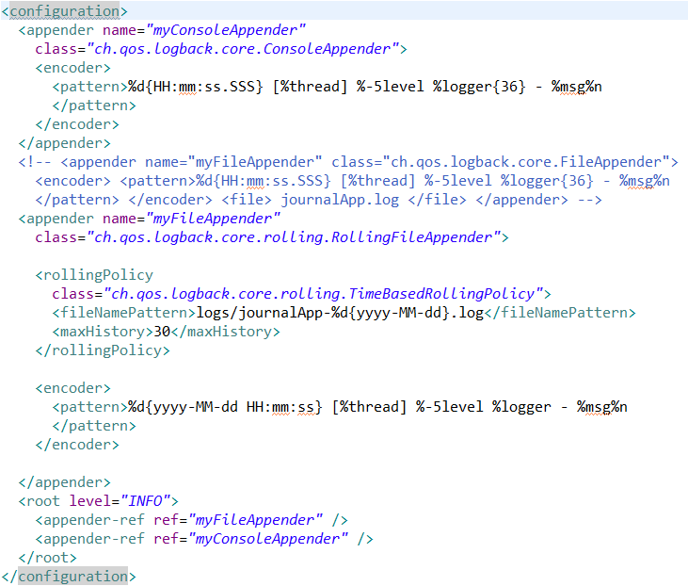
Quality Assessment
Quality assessment represent the strength and vulnerabilities of a code. This can be checked with the help of sonarcube/sonarcloud/sonarlint.

Input Validation
Validating the structure of input data against the static format is necessary to avoid the runtime exceptions. The dependency used here is :
<dependency>
<groupId>org.springframework.boot</groupId>
<artifactId>spring-boot-starter-validation</artifactId>
</dependency>
Some annotations used before Entity class :
@NoTNull
@NotBlank
@Min
@Max
@Size(min = 3, max = 20, message = "Username must be between 3 and 20 characters")
@Email(regexp = "[a-z0-9._%+-]+@[a-z0-9.-]+\\.[a-z]{2,3}")

To use these validations use @Valid as function parameter.
public ResponseEntity<ApiResponse<JournalEntry>> createEntry(@Valid @RequestBody JournalEntry myEntry)
API Documentation
It is the process of visualize/test the API that we have either built or want to design.
Swagger is the tool, which helps us to do so. It is included in the openapi dependency.
<dependency>
<groupId>org.springdoc</groupId>
<artifactId>springdoc-openapi-starter-webmvc-ui</artifactId>
<version>2.8.14</version>
<scope>compile</scope>
</dependency>

Endpoint to access this : http://localhost:8080/swagger-ui/index.html
Generally the API that we have implemented, can be accessed here but for the API that we will design are needed to be stored in specific path and needed to be configured in application.yml file.

Path: /journalApp/src/main/resources/static/api-spec.yaml
application.yml:
springdoc:
swagger-ui:
urls:
- name: Journal Application URLs
url: /v3/api-docs
- name: Sv Lab
url: /api-spec.yaml
- name: Device Management System
url: /openapi.yaml

API Response
For better communication, the API response should be common for all type of activities like success and errors. It provides a common way to represent the data, error messages and HTTP Status Codes.

@Data
@Builder
@AllArgsConstructor
@NoArgsConstructor
public class ApiResponse<T> {
private String status;
private int code;
private String message;
private T data;
private List<ErrorDetail> error;
private Meta meta;

@Data
@AllArgsConstructor
public static class ErrorDetail {
private String field;
private String message;
}

@Data
@AllArgsConstructor
@NoArgsConstructor
public static class Meta {
@JsonFormat(pattern = "yyyy-MM-dd HH:mm:ss")
private LocalDateTime timestamp = LocalDateTime.now();
}
}

This is a structure, to access this use a implementor/builder class as:

public class ApiResponseBuilder {
public static <T> ApiResponse<T> success(T data,String message,int code){
return ApiResponse.<T>builder()
.status("SUCCESS")
.code(code)
.message(message)
.data(data)
.error(Collections.emptyList())
.meta(new ApiResponse.Meta())
.build();
}
public static <T> ApiResponse<T> error(String message, List<ApiResponse.ErrorDetail> errors, int code) {
return ApiResponse.<T>builder()
.status("ERROR")
.code(code)
.message(message)
.data(null)
.error(errors)
.meta(new ApiResponse.Meta())
.build();
}
}

This structure can be passed as a response to the any method or global exception handler in case of error. In case of success, the error list is empty and in case of error, the data is null.

Global Exception Handling
This is the best approach where a central configuration file is created, which tells what to show in case of something happens.
A class is annotated with @RestControlleAdvice is used to mark that class as the source of exception handling along with this some custom exceptions are need like JournalNotFoundException, UserNotFoundException, ResourceNotFoundException

The below is a class which implements Exception Handling Advice
@Hidden
@RestControllerAdvice
public class ApplicationErrorHandler {

@ExceptionHandler(ResourceNotFoundException.class)
public ResponseEntity<ApiResponse<?>> handleNotFound(ResourceNotFoundException ex) {

ApiResponse.ErrorDetail error = new ApiResponse.ErrorDetail("resource", ex.getMessage());

return new ResponseEntity<>(ApiResponseBuilder.error("Resource not found", List.of(error), 404),
HttpStatus.NOT_FOUND);
}

@ExceptionHandler(IllegalArgumentException.class)
public ResponseEntity<ApiResponse<?>> handleBadRequest(IllegalArgumentException ex) {

ApiResponse.ErrorDetail error = new ApiResponse.ErrorDetail("request", ex.getMessage());

return new ResponseEntity<>(ApiResponseBuilder.error("Invalid request", List.of(error), 400),
HttpStatus.BAD_REQUEST);
}

@ExceptionHandler(MethodArgumentNotValidException.class)
public ResponseEntity<ApiResponse<?>> handleValidationErrors(MethodArgumentNotValidException ex) {

List<ApiResponse.ErrorDetail> errors = ex.getBindingResult().getFieldErrors().stream()
.map(err -> new ApiResponse.ErrorDetail(err.getField(), err.getDefaultMessage())).toList();

return new ResponseEntity<>(ApiResponseBuilder.error("Validation failed", errors, 400), HttpStatus.BAD_REQUEST);
}
@ExceptionHandler(UserNotFoundException.class)
public ResponseEntity<ApiResponse<?>> handleUserNotFound(UserNotFoundException ex) {

ApiResponse.ErrorDetail error = new ApiResponse.ErrorDetail("username", ex.getMessage());

return new ResponseEntity<>(ApiResponseBuilder.error("User not found", List.of(error), 404),
HttpStatus.NOT_FOUND);
}
@ExceptionHandler(JournalNotFoundException.class)
public ResponseEntity<ApiResponse<?>> handleJournalNotFound(JournalNotFoundException ex) {

ApiResponse.ErrorDetail error = new ApiResponse.ErrorDetail("journalId", ex.getMessage());

return new ResponseEntity<>(ApiResponseBuilder.error("Journal not found", List.of(error), 404),
HttpStatus.NOT_FOUND);
}
@ExceptionHandler(Exception.class)
public ResponseEntity<ApiResponse<?>> handleGenericException(Exception ex) {

ApiResponse.ErrorDetail error =
new ApiResponse.ErrorDetail("server", ex.getMessage());

return new ResponseEntity<>(
ApiResponseBuilder.error("Internal server error", List.of(error), 500),
HttpStatus.INTERNAL_SERVER_ERROR);
}
}

Filter and Interceptor
Filters are associated with DispatcherServlet. They run before the spring context, and implemented generally at gateway level and used frequently for Authentication/RateLimiting purpose.

On the other hand Interceptors run after the spring context is initialized. They keep track of the request, response and uri.
They contains methods like preHandle, postHandle, afterCompletion. Interceptors are customised by implementing them to a class.

public class InterceptorA implements HandlerInterceptor {
public boolean preHandle(...) {
System.out.println("Interceptor A");
return true;
}
}

They are also needed to be added into the config with
@Configuration
public class MyConfig implements WebMvcConfigurer {
@Override
public void addInterceptors(InterceptorRegistry registry) {
registry.addInterceptor(new InterceptorA());
registry.addInterceptor(new InterceptorB());
}
}

We can create multiple filters and multiple interceptors and then we have to register them.
Rate Limit Control
It is the necessary aspect of the application for the protection against flodding. To achieve this, we have to create a filter that handles the logic of rate limit.
This feature is provided by bucket4j in spring boot. Documentation-> https://github.com/bucket4j/bucket4j
Dependency:
<!-- For java 17+ -->
<dependency>
<groupId>com.bucket4j</groupId>
<artifactId>bucket4j_jdk17-core</artifactId>
<version>8.17.0</version>
</dependency>

Basic logic is create a map that contains the Ip of each user and adds a bucket for them. The bucket contains the logic how many requests can be processed with the rate.

@Component
public class RateLimitFilter extends OncePerRequestFilter {

private final Map<String, Bucket> cache = new ConcurrentHashMap<>();
private final HandlerExceptionResolver resolver;
public RateLimitFilter(@Qualifier("handlerExceptionResolver")HandlerExceptionResolver resolver) {
super();
this.resolver = resolver;
}

private Bucket resolveBucket(String key) {
return cache.computeIfAbsent(key, k -> {
return Bucket.builder().addLimit(limit -> limit.capacity(10).refillGreedy(10, Duration.ofMinutes(1)))
.build();
});
}

@Override
protected void doFilterInternal(HttpServletRequest request, HttpServletResponse response, FilterChain filterChain) throws ServletException, IOException {
String ip = request.getRemoteAddr();
Bucket bucket = resolveBucket(ip);

if (bucket.tryConsume(1)) {
filterChain.doFilter(request, response);
}
else {
resolver.resolveException(request, response, null, new RateLimitExceededException("Try again in 1 minute"));
}
}
}

